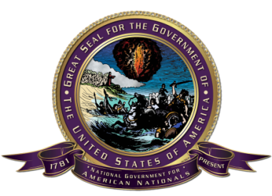
The Government of The United States of America
Rural Free Delivery Route 1
The office of the Secretary of State
Box #2
The United States of America
Global Postal Code-NAC: 8DNBX PPJ78
c/o 18 Harding St.
Johnstown, State of Pennsylvania. 15905
Office hours: 9:00 - 9:00 UTC-6 Monday - Friday
Phone: (951) 389-0313
Email: secretary-of-state@narrowway.support

On the 254th day, in the year of Yahweh, six thousand and twenty four, translation the twenty eighth day of November, two thousand and twenty two, at approximately 7:15 p.m. Universal Time -6, the American Nationals for the Government of The United States of America, and all other interested persons convened a meeting for the assembly, identified as 20221128-SOS-OAR.

Official Assembly Record

BE IT RESOLVED, a motion to create a Legal Representation department within the North American National Party; and

BE IT RESOLVED, the meeting for the National assembly adjourned on the 254th day, in the year of Yahweh, six thousand and twenty four, translation 28th day of November, two thousand and twenty two, at approximately 8:05 Universal Time -6 to re-convene at a future date certain.

Thomas Frank Goudey - Secretary of State
The United States of America
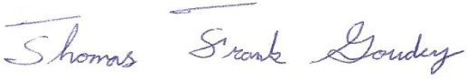

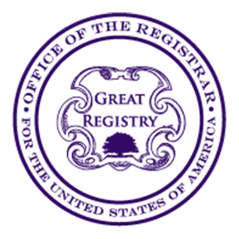
The Government of The United States of America
Rural Free Delivery Route 1
office of the registrar
Box #4
The United States of America
Global Postal Code-NAC: 8DNBX PPJ78
c/o 18 Harding St.
Johnstown, State of Pennsylvania. 15905

Office hours: 9:00 - 9:00 UTC-6 Monday - Friday
Email: registrar@theseunitedstatesofamerica.country

ACKNOWLEDGEMENT

I, Michaelene Jo Formanack, certify under penalty of bearing false witness under the laws of The United States of America that the foregoing paragraph is true and correct according to the best of my current information, knowledge, and belief.

The office of the registrar accepts and acknowledges the document:

Official Assembly Record

254th day in the year of Yahweh, six thousand and twenty four, and the 28th day of November two thousand and twenty second year of the new covenant in Yahushua’s name
Document Date

10:03 UTC-6 RH-20221128-10E2-479C-B373-4400F4591FEF
Time Record File Number

CERTIFIED COPY OF RECORDED DOCUMENT
This is a true and exact reproduction of the document officially recorded
and placed on file in the office of the registrar for The United States of America.

Date Issued: 258th day, in the year of Yahweh, 6024
Translation: 2nd day of December 2022

This copy is not valid unless displaying the Record File Number, Seal, and signature of the registrar for The United States of America.
